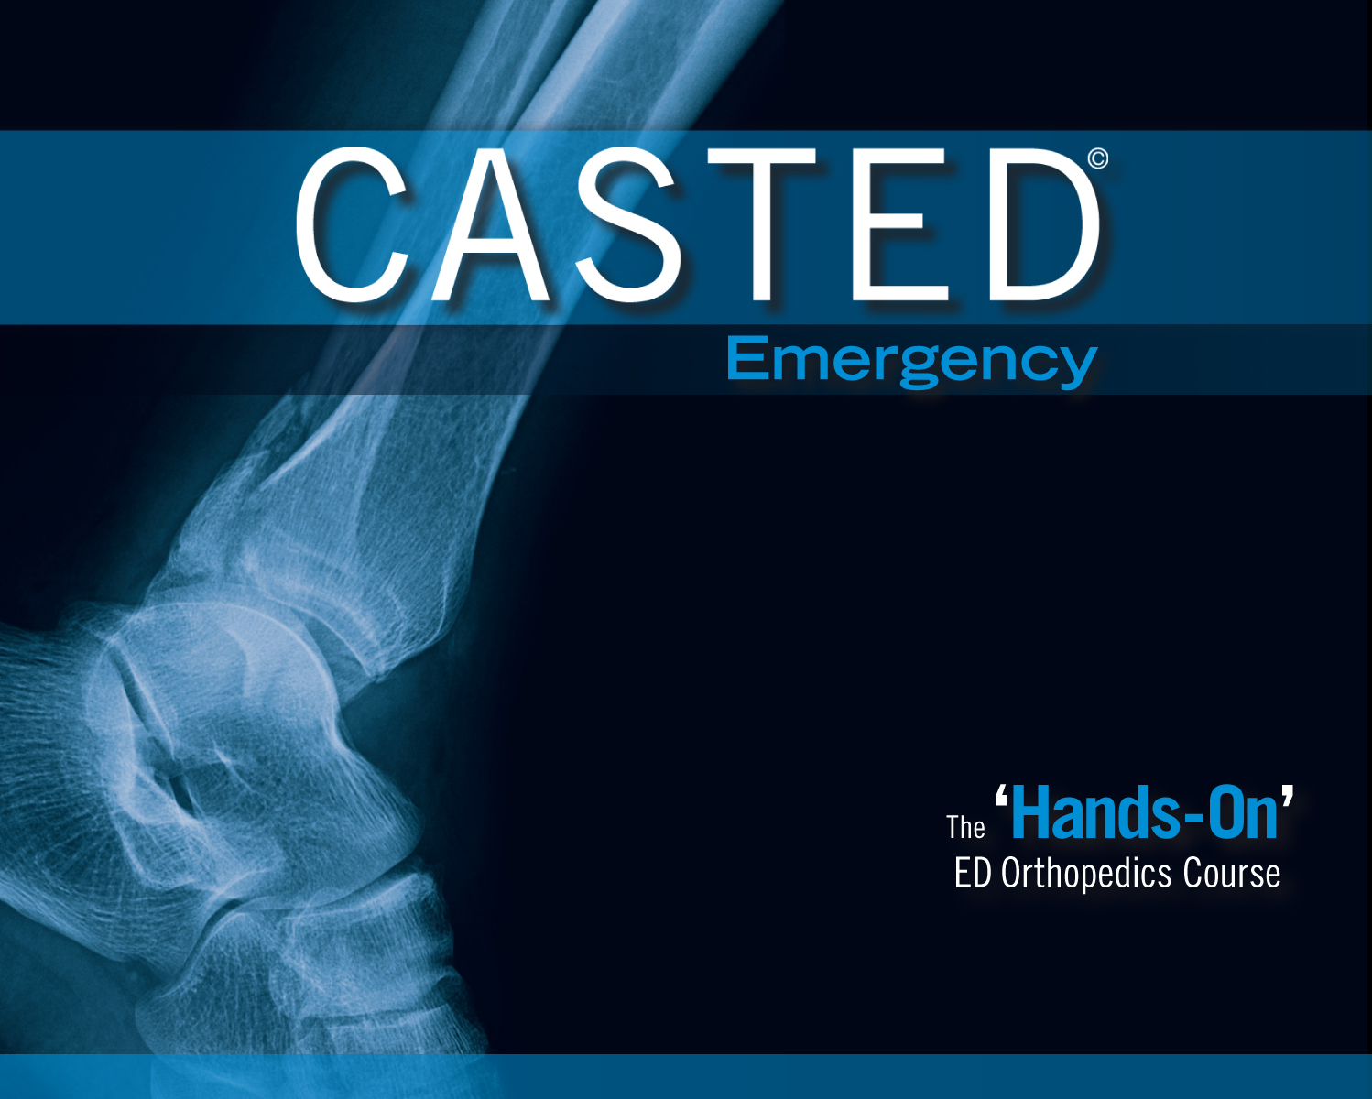

CASTED is the comprehensive ED orthopedics course that combines case-based lectures with extensive hands-on practice.

CASTED is ruthlessly clinical - with complete focus on what helps you better manage your patients on your next shift.

After the course, you will be better at:
1) diagnosing important injuries that are commonly missed
2) ED immobilization and molding
3) risk-stratifying your ED ortho patients - knowing who can be managed locally, who needs to see ortho and when.

You will have a much better understanding of ED ortho. You will empower your clinical skills.

We are honoured to again offer a 2-day CASTED course in conjunction with SRPC's Rural and Remote Conference as a Pre-Course. April 2-3, 2019

CASTED course details and registration is done online. [Details/Registration]

